**FOR-LOOP WITH DATES**

**Init value**  @[User::StartValue]

**Condition**  DATEDIFF("Day", @[User::StartValue] , @[User::EndValue] ) >=0

**Assign**  @[User::StartValue] = DATEADD("Day",1, @[User::StartValue])

In each iteration of the loop, the For Loop container evaluates an expression and repeats its workflow until the expression evaluates to False.   
  
The For Loop Container uses the following elements to define the loop:

* An optional initialization expression that assigns values to the loop counters.
* An evaluation expression that contains the expression used to test whether the loop should stop or continue.
* An optional iteration expression that increments or decrements the loop counter.

The following example shows a For Loop container displaying Current Value of Expression through Message Box.

1. Add two package variables - **StartValue** and **EndValue**, both of integer type.

[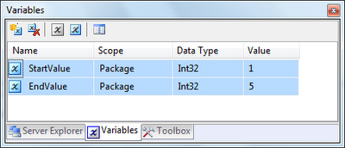](http://4.bp.blogspot.com/_2t15yG-FxQA/TBsK-rr40tI/AAAAAAAAAoc/ZzRrux1sxWA/s1600/1.png)

2. Drag and drop **For Loop Container** from toolbox and double click on it to open **For Loop Editor**. And Set the following values

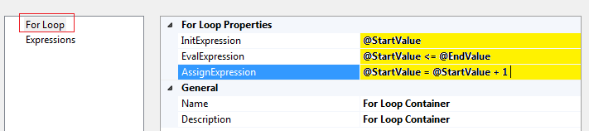

This loop repeats five times because StartValue is set to 1 and EndValue is set to 5.

3. Drag and drop **Script Task** inside For Loop Container and double click to open **Script Task Editor**.

Type **User::StartValue** in **ReadOnlyVariables** property of script Task editor.

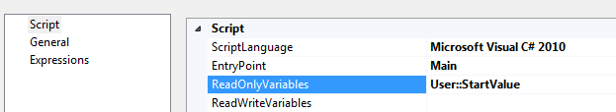

Now Click on **Edit Script...** button to write code  
  
4. Write following code in Main() function to display a message box for current value of StartValue variable in loop iteration:

public void Main()

{

MessageBox.Show("StartValue = " + Dts.Variables["User::StartValue"].Value.ToString());

Dts.TaskResult = (int)ScriptResults.Success;

}

5. Close script task editor and save changes. Now right click on Package in Solution Explorer and click **Execute** to execute the package.

[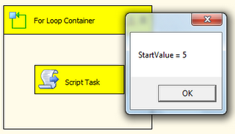](http://3.bp.blogspot.com/_2t15yG-FxQA/TBscYyPyjoI/AAAAAAAAAo0/_VtNCBusRZc/s1600/1.png)

The package will show Message box 5 times before completion.